|  |  |  |
| --- | --- | --- |
| Safety Gadget for Child Safety Monitoring and  Notification  IBM NALAIYATHIRAN      Project Development –Delivery of Sprint 4  Connecting the Node-Red Service and MIT app With Web UI  and Show the child location and notify | | |
|  | TITLE | IOT based child safety gadget for child safety monitoring and notification |
| DOMAIN NAME | INTERNET OF THINGS |
| TEAM ID | PNT2022TMID50609 |
| TEAM LEADERNAME | SELSHIA M |
| TEAM MEMBER NAME | SANDHIYA SUBASHREE M  SUBHASHINI G  BANUPRIYA K |
|  |  |
|  | |

Connect the app with Node-Red Serivce:

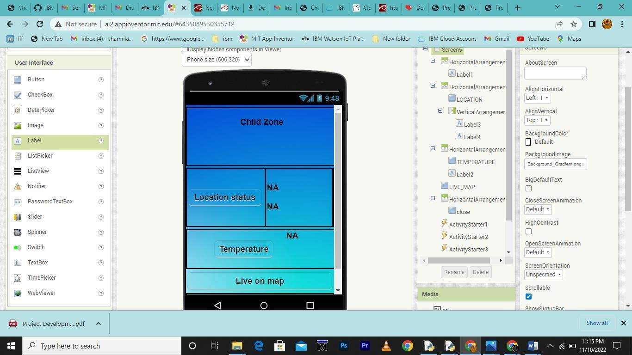

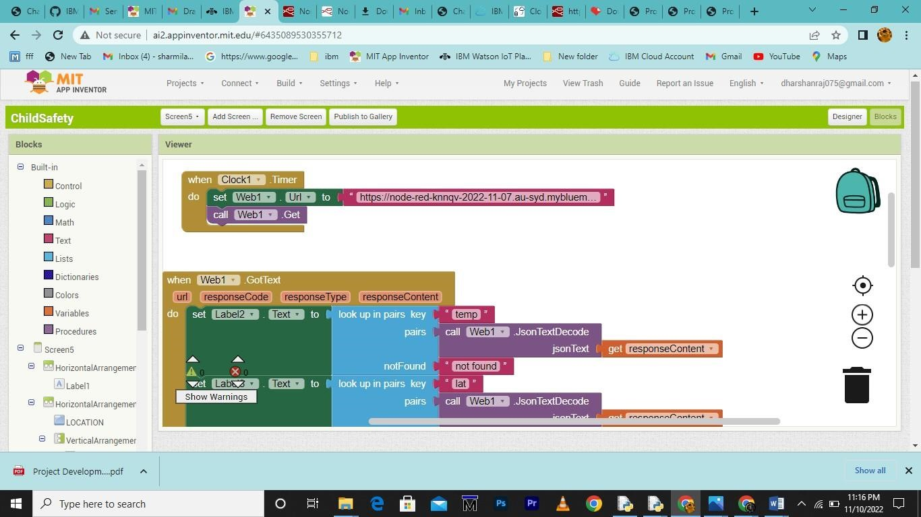

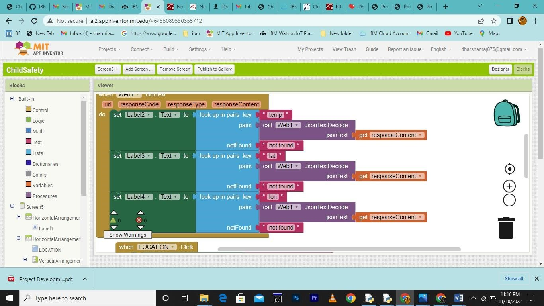

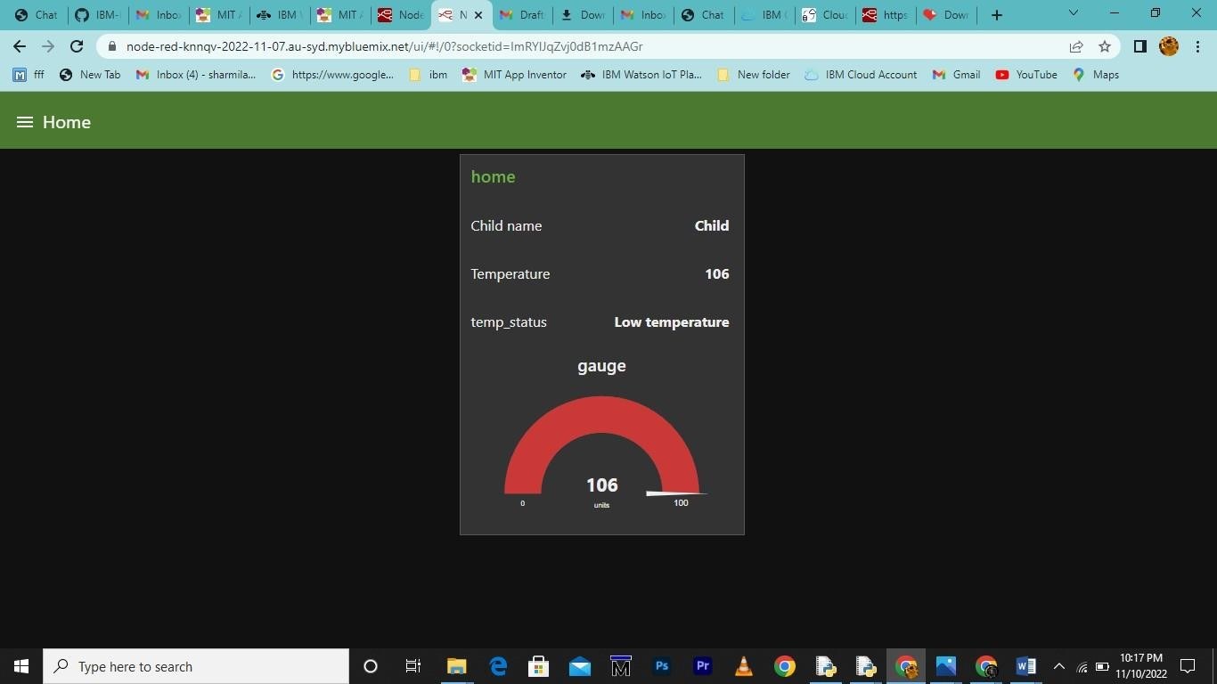

Web UI:

